INGATESTONE CHRISTMAS MARKET

SUNDAY 8TH DECEMBER 2019

Organised by | and |  | Ingatestone & Fryerning Community Association CIO

Stallholder Application Form

Stallholder Pitch Fees
Unless agreed otherwise the purchase of a pitch or pitches includes the space only and does not include the stall, tables, gazebo or other hardware which must be provided by the stallholder. All gazebos used must have side panels, weights and be sufficiently sturdy to withstand winter weather.

Ready Assembled Stalls  This year we will be providing a number of ready assembled market style stalls of the dimensions shown below. These have a built-in table and overhead canopy as shown. Booking of a single stall will mean the allocation of one half of a double stall as shown. Bookings will be subject to availability. | Dimensions  A 2.13 m / 7 ft.  B 1.98 m / 6 ft 6  C 1.37 m / 4 ft 4  D 0.76 m /2 ft 6  E 0.91 m /3 ft .  F 0.74 m / 2 ft 4

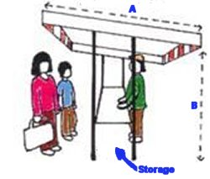 | 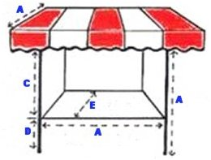 | 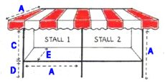
Side View – Single Stall | Front View - Single Stall | Front View Double Stall

Stalls and pitches available |  |  | Cost per stall  or pitch
 | A | Single Assembled Stall (2.13m x 2.13m) | £45
 | B | Double Assembled Stall (4.26m x 2.13m) | £90
 | C | Pitch only (3m x 3m) | £35
 | D | Double pitch only (6m x 3m) | £70
 | E | Hot Food Vendors (per pitch) | £85

Your Name
Trading Name
Address for sending material
Your email
Contact Tel.No.
Type required (A,B,C,D or E |  |  |  | No. of pitches required |  |  | Size of your stall or van (pitch bookings only)
Subject/Craft and whether power required
Website | www.
 | If accepted, this will be used when advertising your presence at the event unless you advise to the contrary. Please don’t just put Facebook or twitter as we will be unable to use this.
All bookings will be subject to the organisers’ Terms & Conditions which are available on our website www.ingatestonechristmasmarket.com

Please complete this form, then amend the file name by inserting your surname, save the document and email the completed form as an attachment to nwagland@hotmail.com

Thank you
Nigel Wagland Telephone 07919 327021

