INGATESTONE CHRISTMAS MARKET
SUNDAY 8TH DECEMBER 2019 - 12 Noon to 6 pm

Organised by  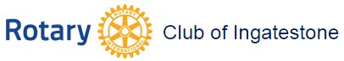 | and | 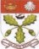 | Ingatestone & Fryerning Community Association CIO

Sponsor Application Form

After last year's successful first Christmas Market in Ingatestone, we are holding the event again this year and again raise money for Rotary and local charities.
We are looking to make it both bigger and better than last year and will be adding many more and a greater variety of stalls, decorating the site more and providing a new stage and entertainment. Once again this year, much of the High Street will be opening and taking part. With extensive advertising on social media and locally, we expect another large attendance from Ingatestone itself and also a wide surrounding area.
As result of the expansion planned, the costs of organising the market will be higher this year and we are hoping to raise funds to help pay for this by offering a wide range of sponsorship packages as follows:-

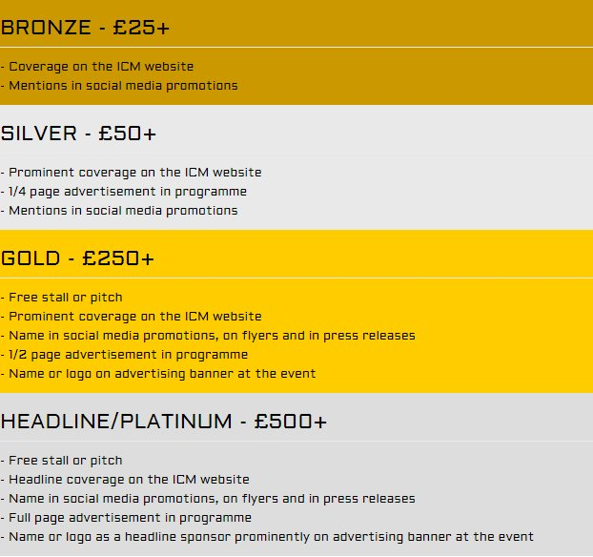

There will also be opportunities to sponsor the stage which can be discussed if you are interested.
We hope that you wish to support this event by being a sponsor this year. If you do, please select your preferred package by completing the form below.
Alternatively, you can mail the details to 6 High Street, Ingatestone CM4 9EE
If you have any questions or there are any other ways you feel that you can support this event, please get in touch.
Thank you
Nigel Wagland
Tel: 07919 327021

We are interested in becoming Sponsors of the Ingatestone Christmas Market
Preferred  Package | Please indicate your preferred package:-
 | Bronze
 | Silver
 | Gold
 | Headline / Platinum
Your Name
Trading Name
Address for sending material
Your email
Contact Tel.No.

Please complete this form, then amend the file name by inserting your surname, save the document and email the completed form as an attachment to nwagland@hotmail.com

Thank you
Nigel Wagland Telephone 07919 327021

